

CCBST
Online Instructor Handbook

2022

Table of Contents

Online Faculty Responsibilities 4
Save our Students (SOS) Procedure and Retention for Online Students 5
Moodle 18
Course Material 18
Adobe Connect 19
Syllabus 22
Textbooks 22
Attendance Policy 22
Grades 23
Communication & Feedback 23
Instructional Methods 24
Professional Development 25
Community Resources 26
Teaching Philosophy 26
Online Division Faculty and Staff 27
Helpful Links: 30

September 21, 2015

Welcome from the Dean:

This is an exciting time to be an online instructor for CCBST. At CCBST, we aim to deliver a new breed of online education that meets the changing needs of students around the world. Students are mobile, connected, and above all, very busy. They want quality rigorous education that is customized for their learning style and needs. The days of everyone learning the same thing, the same way, measured by time in the seat is yesterday’s news. We have adopted a curriculum development method that will allow us to redesign the delivery of courses quickly, with many iterations as technology becomes better, our understanding of the needs of students increases, and the faculty move from a place of “giver of knowledge” to a mentor. Your job is to become a cohesive team, to mentor our students, and to make everyone feel like family. We have given you a voice through Adobe Connect so you can meet face to face with students and engage in life changing discussions, networking, and introductions to the field.

I look forward to working with each of you. As you read through this guide, you will find important information that will help you adapt to the structure of online. We are excited to have you as part of our team, and we welcome your comments and suggestions as we make this journey together.

Regards,

_______________________
Online Campus Dean

“Around here, however, we don’t look backwards for very long. We keep moving forward, opening up new doors and doing new things, because we’re curious…and curiosity keeps leading us down new paths.”

~ Walt Disney

Online Faculty Responsibilities

Engage, engage, engage! You have the stories from the field that students want to hear. Tell them. Talk to your students weekly, hold live sessions that you record for those who can’t make them, individually mentor students through their projects. Connect! Help students to build a network. You are the expert in the field. Help your students engage with important players in the field who can help them learn and succeed. Introduce them, bring in speakers through Adobe

Connect, and draw on global contacts.

Give Feedback! Students want your feedback. They want to know how they can improve, so talk to them. We ask that you respond to student questions within 24 hours. When you grade work, give detailed feedback. Encourage students with what they are doing right.

Grade on Time! Each week students should know where they are in their learning. Prompt grading using the rubrics is important. A 48 hour turnaround is expected.

Use the Rubrics! The rubrics are based on competency. To be competent means that a person has the entry level skills and knowledge for the career they are pursuing. This will be different at the undergraduate and graduate level. While we hate to put letter grades to it, until we become fully competency based, Competent equates to a B. In order to get to Exceeds Competency, an A, the student must demonstrate that they have much deeper knowledge and application. Most students will be at the Competent or Developing Competency level. When grading with a rubric it is essential that you stick to the rubric and do not add to it or take away. Also, it is tempting, when we are the expert, to expect more than what is reasonable at this level.

Encourage, encourage, encourage! We want students to feel part of a family where we care and are truly interested in them. Please avoid giving penalties for late work, or other issues unless it is part of the rubric.

Be flexible with authentic learning. In other words, if a student is actively involved in a project at work that they would like to bring into their class, work with them. It doesn’t make any sense to make them do the marketing project in the course if a more authentic one allows them to learn more. Just try to keep the same rigor and basic content. Be present and visible. Nothing causes students to complain more than when they are looking for an answer to their question and the instructor seems to have disappeared. We ask that you check into your Moodle daily if only for a short period so that student questions do not go unanswered; make yourself known. Find a time that works for you to be available. Set up regular appointments with students to chat. Discussion boards are deadly and boring if no discussion occurs. As the instructor you need to be an active participant in the discussion. Use Socratic questioning, prompts, and even play “devil’s advocate” to get students to engage in more critical thinking.

Save our Students (SOS) Procedure and Retention for Online Students

The purpose of this procedure is to identify online students at risk and work with them to achieve success in the classroom and in their overall program. This early intervention is a proactive best practice to save our students and consists of the following steps:

- Week 4

  - Individual Action Plans are issued by instructors.
  - The “Start of the Quarter” Retention Initiative Report, generated by individual professors, is sent to OL Student Support.
  - Faculty Leads retain a copy of the report.

- Week 6

  - Individual Action Plans are issued by instructors.
  - The “Mid Quarter” Retention Initiative Report is sent to OL Student Support
  - Faculty Leads retain a copy of the report.

- Week 8

  - Individual Action Plans are issued by instructors.
  - The “End of the Quarter” Retention Initiative Report is sent to OL Student Support
  - Faculty Leads retain a copy of the report.

Your Faculty Lead will provide you with a copy of the Individual Action Plan form (to be completed with each student at risk –- D and F grades) and the Retention Initiative Report (spreadsheet to complete with a summary of the Action Plans).

- Week 6
- Individual Action
- Faculty Leads retain a copy.
Week 6
Faculty Leads retain a co

Moodle (Examcenter)

Moodle is a digital platform to post assignments and interact with students. As an online instructor, it is imperative that you obtain your credentials immediately. To log on, navigate to the CCBST Examcenter homepage (https://www.examcenter.CCBSTCollege.com/) and Click “Log in” at to right corner to begin.

● Examcenter Guide for Faculty
● Teacher Examcenter Training

For Examcenter troubleshooting, please contact: ____________________________________________________________

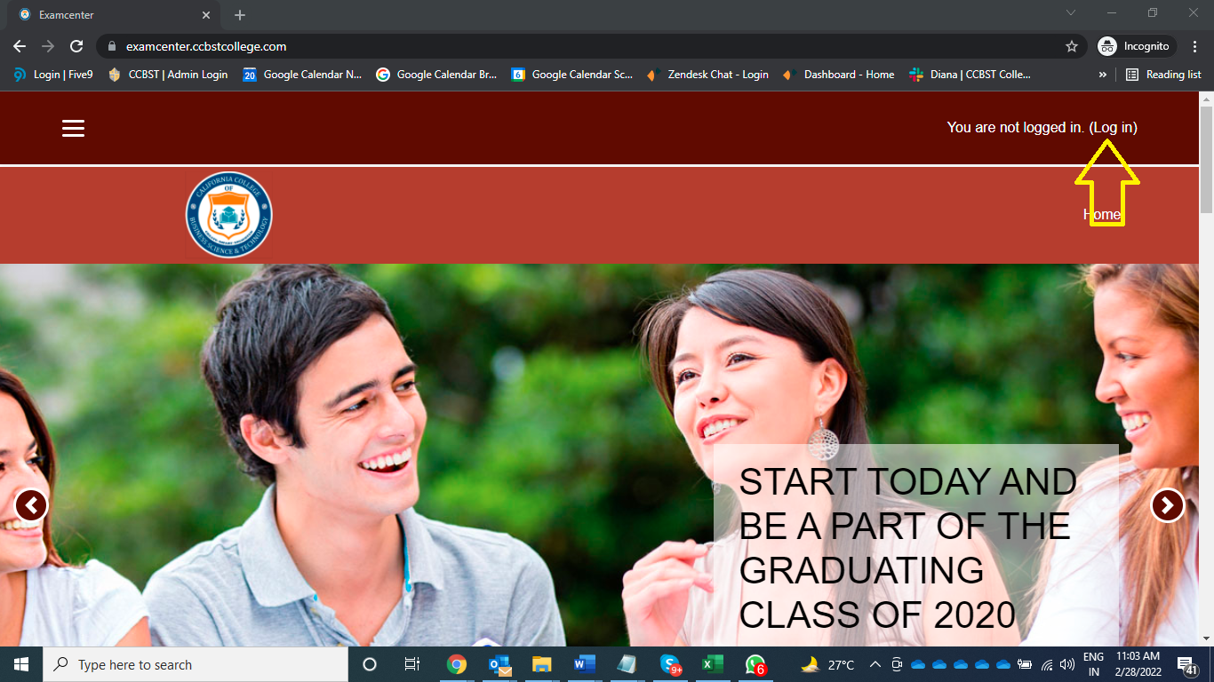

Course Material

Please do not add or delete anything from the Moodle course material, as it is been standardized through all the courses of CCBST. If you have a question about this, please contact your Faculty Lead. You may add weekly course announcements and one WIKI forum to encourage students’ engagement. But please do not add weekly discussion boards or any other type of information, without first communicating with your Faculty Lead.

Always post your bio and contact information to the left of the course contents, within the appropriate block.

Zoom

As an online instructor at CCBST you are required to hold at least 3 Zoom live classes per week. Please post in your Examcenter classroom (under “announcements”) your Zoom schedule, at the beginning of each week.

Zoom is a web conferencing tool used for online courses. This tool allows for greater engagement between professor and students in the digital environment. To ensure that instructors are proficient with the software, new hires must complete training through LYNDA.com and generate a certificate of completion, which should be shared with your Faculty Lead.

● ZOOM

New online instructors must complete the Online Instructor Certificate Training Program, even if they have been on ground instructors for CCBST. Please contact your Faculty Lead if you have not completed this program. This program consists of self- paced online short courses.

Zoom Best Practices

1) Prepare for Zoom instruction
- Practice using Zoom in advance.
Test your audio and video. Be sure light is on your face and that your background and desktop are free of distractions. Practice looking at your webcam, not the screen when you present. Practice sharing your screen.

- Review your host controls and meeting settings.
Determine whether you’ll include other hosts or co-hosts, mute participant microphones (muting recommended for large groups), or record the session for use at a later time.
- Consider making slides or discussion questions available in advance in examcenter, etc. so that students can access the content if screen sharing does not work.
- Anticipate potential challenges including the possibility that students don’t have ideal connections and aren’t able to hear and see everything perfectly.

2) Use screen sharing to share your screen or slides as you speak
- Display an agenda at the start of the class session so that students know what to expect of the shared time together.
- Narrate the material that you’re displaying visually on the screen. Just as you might read materials aloud in class, read screen material that you share on-screen just in case students are not able to see essential text.
- Post discussion questions in your slides so these can be visible to students who may have a slow Internet connection or who may struggle to hear the audio.

3) Use the chat tool to connect regularly with students during meetings
- Use chat to troubleshoot technical problems at the start of a meeting. If you have a TA who can support the class instruction with technical help, this would also be a good person to respond to troubleshooting tips in the chat.
- Check the chat often to identify student questions and areas of interest or confusion. For larger classes, assign a TA to moderate the chat and make sure important questions and comments are addressed. Even for smaller classes, it may be worthwhile to ask a student (or two) to take on special roles as “chat monitors” to voice if there are questions that arise that the instructor has missed.
- Use chat to engage students in discussion. Pause often during a lecture to ask a question and invite students to answer or comment. “Call on” students with a text question or comment to elaborate.

4) Use active learning and collaboration tools to make the class more interactive
- Use polling tool within Zoom to collect student responses, and then share results with both in-person and online students.
- Use breakout rooms to help students talk in smaller groups, just as they would do break-out groups in a larger class environment. As the instructor, you can visit the breakout rooms, broadcast messages to various rooms, and end the breakout sessions when it is time to regroup.
- Consider asking students to work together as a large group or breakout groups on a shared Google Doc.

5) NOTIFICATION OF STUDENTS

a) POST ON MOODLE
Post all Adobe Connect meeting dates and times along with the URL at the top of Moodle and email this announcement page.

b) EMAIL REMINDER
Email a reminder for the upcoming meeting to all students a few days prior to the meeting. Make sure to include the date, time, and URL link for the meeting.

For additional support regarding Adobe Connect please contact Professor __________________________________at ________________________________for a training session.

Syllabus

Each professor is responsible for completing a syllabus template for every course they teach. Instructors need to populate the document with contact information, assignment dates, and other data pertinent to the course.

Syllabus for preformatted courses can be found in the course shell. Please update the syllabus with your personal information (bio, pic, email, etc.) and send it to your Faculty Lead for re-linking. For courses that have not been pre-formatted, please ask your Faculty Leads for a copy of the syllabus.

Textbooks

Online faculty members are assigned E-books for each course. To access them, you will receive a passcode from Elise Straub, Learning Resource Coordinator. Please contact _____________________________ at ______________________________if you have issues accessing the content.

Refer any student textbook questions to: ____________________________________
*Please note: that not all courses require books; some of the texts and academic material (i.e. academic journals articles, etc.) are embedded in Moodle.

Attendance Policy

To be counted for attendance, online students have to submit some form work by the end of the week (Sunday at midnight). This includes significant contributions such as composing and submitting drafts for instructor’s review, attending Adobe Connect sessions, or making a post on the discussion boards. Professors are to submit attendance via the Self-Service portal every Monday by 5pm. Recognize low student participation and minimal contributions and be aware of students that “disappear” from the classroom. Contact your Faculty Lead, if you are experiencing this problem. Logging in the classroom and “viewing” material only, is not considered “attendance”. Please check under “Reports” and “Logs” in the Moodle classroom, in order to obtain information about students’ participation.

Please place the online attendance policy in the “announcements” board in your classroom in the first day of class.

Grades

Due dates for mid-term and final grades will be set by the University Registrar. Your Faculty Lead will advise you of the due date and will send you a reminder. It is up to the discretion of the professor to assign due dates for other assignments. Grades should be posted within 48 hours of submissions in the Moodle Classroom Gradebook. Feedback to students should be placed in the gradebook, next to the grade. Please post midterm grades in the Self Service Portal by the end of week 5, by the deadline stipulated by the Registrar and your Faculty Lead. Final grades should also be posted by Week 10 in the Self Service Portal. Fail to post grades on time will cause all kinds of issues across the University (i.e. student retention, financial aid, etc.). So please be prompt with your grading.

If you encounter any technical issues associated with posting grades, contact your Faculty Lead immediately.

Communication & Feedback

● Respond to student emails within 24 hours whenever possible. Building a positive rapport with online students is the key to student success and to an overall friendly and positive classroom environment. Phone calls should be returned promptly and a summary of the conversation should be posted in the Moodle classroom (under individual “messages” to students).

● Adopt a positive and professional tone when communicating with students.

● Always communicate through the Moodle classroom in order to keep a record of your communications. Avoid communications outside the classroom.

● Post weekly announcements that summarize upcoming activities (example, Adobe Connect Live Sessions) and assignments.

● Maintain presence in the classroom (check in your classroom daily) and focus on quality interactions; provide enough interactions so students do not feel isolated.

● The wording of your feedback should be positive with constructive criticism and goals to achieve in future assignments.

● Try implementing the “Sandwich Feedback” approach; start by highlighting the positive elements of the assignment, state your constructive criticism, and end the feedback with words of encouragement.

● Feedback should be in depth, but no excessive; place your feedback in the grade book on Moodle.

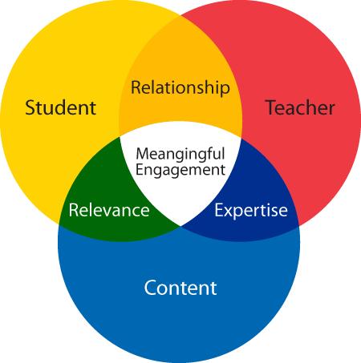

Instructional Methods

We believe that individuals construct understanding as they actively engage with interactive lessons, games, discussions, and each other. You will find no lecture here, no boring PowerPoints, and no classrooms. The world is our classroom and we want to make use of every part possible. All of our graduate courses are project based and consist of five modules that can be completed in up to 10 weeks. Undergraduate courses are scenario based and are laid out in ten modules. Some of the tools available to you to enhance your teaching/learning experience include:

● Adobe Connect for live sessions –- you can share your desktop, documents, videos, and whiteboard. You can place students into teams for breakout sessions. And you can use it as a place for students to make presentations, debates, and other active engagement.

● Video -– you will find that most video you access through links. This is important because of copyright laws. We do have an in-house production studio that is building our own video collection stored in our own YouTube.

● Moodle Rubrics -- these are built in rubrics that are automatically calculated as you electronically score them and then sent to the grade book.

● Resources -- we have access to a wide selection of resources including video, research papers, e-books, and other publications through our online library databases. We encourage you to add to the Resources section from here. Our aim is to stop using textbooks and rely on more current relevant resources.

● Interactive lessons, especially in the undergraduate programs that allow students to test their understanding, engage in an experiment such as extracting DNA from strawberries, or experience what happens when certain chemicals are mixed.

● Animation to engage students in learning new concepts.

● Case studies for authentic application of learning.



Professional Development

Faculty members are required to stay current with the latest trends and developments associated with their discipline. This includes, but is not limited to: webinars, trainings, conferences, and specialized memberships programs. If you participate in a professional development activity, please make sure to forward documentation and CCBST professional development form to your Faculty Lead. Supporting materials can include registration documents, certificates, and professional membership confirmations. The required professional development activity for this quarter is the LYNDA Adobe Connect Essential Training.

Community Resources

Each quarter, instructors should include a community based assignment within their curriculum. This can include guest speakers, volunteer assignments, or events related to the course. First, complete a Community Resource request form outlining how the activity will benefit the learning objective. Make sure that the students record the activity with supplementary material. This can include pictures, sign-in sheets, event registrations, or records of volunteer hours. Submit the documents and completed Community Resource Form to your Faculty Lead.

Teaching Philosophy

Distance learning is a unique educational experience. CCBST encourages its academic staff to not just lecture and recite information, but rather inspire and engage our student body. As an Innovation member and academic mentor, you are responsible for professional guidance as well as fostering collaboration and critical thinking skills. Feel free to be creative with incorporating digital resources and presenting information within an online environment.



Online Division Faculty and Staff

Faculty Leads

Each department within the Online Division is managed by a Faculty Lead. They work with a team of up to 20 faculty members. In this capacity, they will help you adjust to the online courses, work with academic issues, develop professionally, and learn to be an outstanding instructor. Expect to see them drop into your class often to see what is happening. If you have any questions related to academic issues, this is the person to contact first. A list of Faculty Leads by Departments can be found at the end of this Manual.

Senior Online Advisor

The Senior Online Advisor is a member of the Student Support Team. They will contact your students at the beginning of the term and each week thereafter to help them get started, find solutions to challenges of school and life, give encouragement to keep going, and generally be their guide, advocate, and overcomer. The Senior Online Advisor will communicate with you often also to see what they can do to help and to discuss students who are having trouble. They regularly pull down data on the classes to see how their students are doing and step in whenever a student shows the potential for high risk. Additionally, the Senior Online Advisor will help the student in registering for classes, along with the Faculty Lead/student advisor.

Helpdesk Support

The IT Support person is the go to person for IT solutions. Whether it is a broken link in your course contents, a grade that won’t automatically post, or a student who can’t access Moodle, they are the person with the expertise. They are highly knowledgeable in IT solutions and in the platforms you will be using here at CCBST. IT Support can be acquired by emailing ____________________________________

Online Student Support

The Online Student Support staff will assist new and existing students with general issues associated with accessing the classroom, textbooks, and other concerns. Please email ________________________________________ if you need general information on online students. Since the Online Division also serves hybrid students who are housed in on ground campuses, questions about hybrid students should be directed to the respective campus Faculty Leads.

Faculty Member Name | Faculty Member Email | Faculty Member Phone Number

Important Resources
NAME | Email | Phone Number
24/7 Tech Support Name

Helpful Links:

CCBST Catalog:

University Catalog

Resources for Online Instruction:

Teaching Online Courses –- 60 Great Resources

TeachOnline -- Arizona State University

Strategies for Online Teaching-University of Michigan

Best Practices-Hanover Research Council

For additional and general information on CCBST academic policies and procedures, please refer to the CCBST Faculty Handbook.


Online Faculty Handbook Acknowledgment

I have received and read the online faculty handbook.

______________________________________________

Print Name

Signature Date

Please complete this acknowledgment and email to your Faculty Lead. Thank you!

